
SRM Institute of Science and Technology
Mode of Exam
OFFLINE
SET A

College of Engineering and Technology
DEPARTMENT OF ECE
SRM Nagar, Kattankulathur – 603203, Chengalpattu District, Tamilnadu
Academic Year: 2021-2022 (EVEN)
Batch 1
Test: CLAT-3 Date: 27/06/22
Course Code & Title: 18ECC202J / Linear Integrated Circuits Duration: 2 Periods
Year & Sem: II year / IV Sem Max. Marks: 50
Course Articulation Matrix: 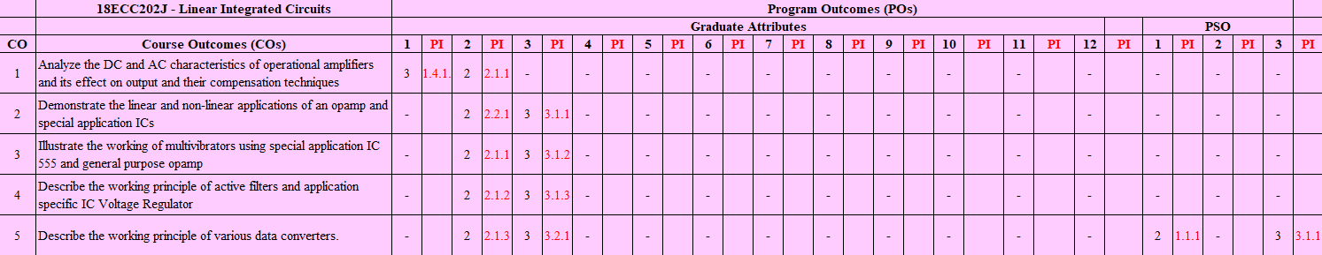

Part - A
(10 x 1 = 10 Marks)
Instructions: Answer ALL
Q. No | Question | Marks | BL | CO | PO | PI
1 | A network that allows a specified band of frequency and attenuates the rest of frequency is called ………………  a. Limiter b. Modulator c. Amplifier d. Filter | 1 | 1 | 4 | 2 | 2.1.2
2 | Narrow band-pass filters are defined as …………….  a. Q < 10 b. Q > 10 c. Q = 10 d. Q = 0 | 1 | 1 | 4 | 2 | 2.1.2
3 | What are combination involved in wide band pass filter  a. BPF and LPF b. HPF and BPF  c. HPF and BSF d. HPF and LPF | 1 | 1 | 4 | 2 | 2.1.2
4 | What is the dropout voltage in a three terminal IC regulator?  a. |Vin| ≥ |Vo|+2v b. |Vin| < |Vo|-2v  c. |V in| = |Vo| d. |Vin| ≤ |Vo| | 1 | 2 | 4 | 2 | 2.1.2
5 | Switching regulator efficiencies can be greater than ________ percent.  a. 60 b. 70 c. 80 d. 90 | 1 | 1 | 4 | 2 | 2.1.2
6 | Which of the following ADC has fixed conversion time?  a. Flash b. Successive approximation  c. Dual slope d. Monolithic | 1 | 1 | 5 | 2 | 2.1.3
7 | Resolution of 4 bit ADC with 10v input is  a. 6.667mV b. 666.67mV c. 66.67mV d. 6666.7mv | 1 | 2 | 5 | 3 | 3.2.1
8 | Timing and sequencing is not required in ---------- ADC.  a. Flash b. Monolithic c. Dual slope d. Successive approximation | 1 | 1 | 5 | 2 | 2.1.3
9 | A monotonic DAC is one whose analog output increases for …….  a. decrease in digital input b. an increase in analog input  c. an increase in digital input d. decrease in analog input | 1 | 1 | 5 | 2 | 2.1.3
10 | The basic step of a 9-bit DAC is 10.3 mV. If 000000000 represents 0 V, what output produced if the input is 101101111?  a. 3.78 V b. 7.38 V c. 8.37 V d. 8.73 V | 1 | 2 | 5 | 3 | 3.2.1
Part – B
( 4 x 10 = 40 Marks)

SECTION B1
Instructions: Answer ANY 2 Questions
11 | Identify the system whose magnitude response is as shown below:  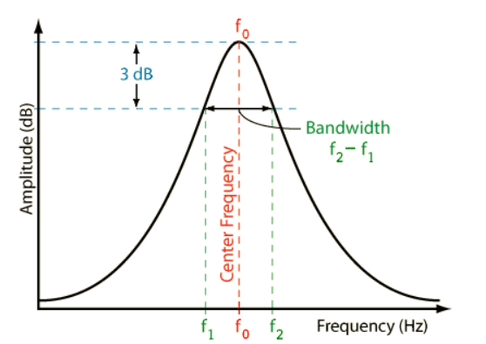  Draw the circuit diagram of the system considering the quality factor to be 80 and derive the expression for transfer function. | 10 | 3 | 4 | 3 | 3.2.1
12 | With a neat circuit diagram, derive the transfer function of all the filters in state variable configuration. | 10 | 3 | 4 | 2 | 2.1.2
13 | Explain the different sections in IC723 general purpose regulator with necessary diagrams and brief the approach for boasting the current. | 10 | 2 | 4 | 2 | 2.1.2

SECTION B2
Instructions: Answer ANY 2 Questions
14 | With a neat sketch, explain the operation of weighted resistor DAC | 10 | 3 | 5 | 2 | 2.1.3
15 | Draw the functional diagram of Dual Ramp Convertor and formulate the output expression. | 10 | 2 | 5 | 2 | 2.1.3
16a | What output voltage would be produced by a DAC whose output range is 0-10V with binary input: (i) 10 (ii) 0110 (iii) 10111100 | 6 | 4 | 5 | 3 | 3.1.2
16b | Calculate the values of LSB, MSB and full scale output for an 8-bit DAC for 0-10V range | 4 | 4 | 5 | 3 | 3.1.2

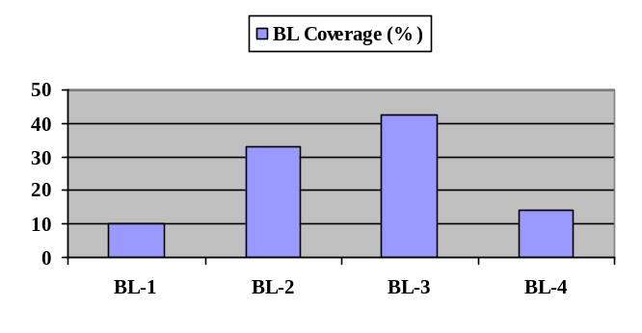Course Outcome (CO) and Bloom’s level (BL) Coverage in Questions
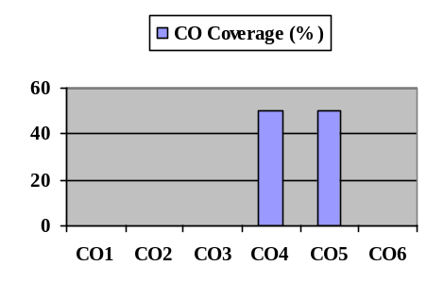

Approved by the Course Coordinator Signature of the Question paper setter

Evaluation Sheet
Name of the Student: Register No.:

Part- A (10 x 1= 10 Marks)
Q. No | CO | PO | Maximum Marks | Marks Obtained | Total
1 | CO4 | 2 | 1
2 | CO4 | 2 | 1
3 | CO4 | 2 | 1
4 | CO4 | 2 | 1
5 | CO4 | 2 | 1
6 | CO5 | 2 | 1
7 | CO5 | 3 | 1
8 | CO5 | 2 | 1
9 | CO5 | 2 | 1
10 | CO5 | 3 | 1
Part- B (4 x 10= 40 Marks)
11 | CO4 | 3 | 10
12 | CO4 | 2 | 10
13 | CO4 | 2 | 10
14 | CO5 | 2 | 10
15 | CO5 | 2 | 10
16a | CO5 | 3 | 6
16b | CO5 | 3 | 4

Consolidated Marks:

CO | Maximum Marks | Marks Obtained
4
5
Total

PO | Maximum Marks | Marks Obtained
2
3
Total

Signature of Course Teacher

Signature of the Course Coordinator Signature of the Academic Advisor

